IFG Explore 1st Year
Term Three – Week One I Luv Uz Spiritual

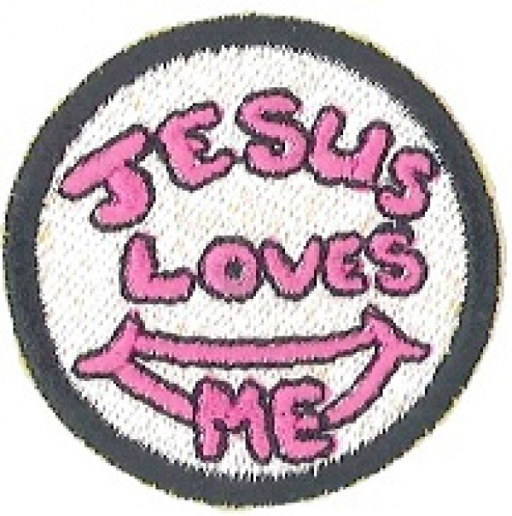
Loving Ourselves

Note: There is an extra activity that is suitable for this topic at the end of the three week session outline.

Aim: To help girls understand that God cares for each one of us therefore we should care about ourselves.

Pre Session Preparation:
- Equipment required – digital camera, laptop, data projector. (If you do not have this equipment maybe you could borrow from your church or a community group)
- Ask girls to bring their hair brush/comb and make sure they wear their IFG uniform. Brush hair ready for a photo.

Pre-SetUp for arrival of girls:
Commence with games that girls can join in as they arrive eg “Captain’s Coming” – see Games resource.

Set Up:
Usual formal start to the programme.

Teaching Session/Activities:
Take individual photos of each girl and leader and project on to screen or blank wall.
Coach’s Tip: If you have a large number of girls in your Unit you will need to start taking photos as they arrive and throughout the games time so girls are not waiting around while all the photos are taken.

Devotions:
(Read Bible verses from Psalm 139 v 13/14 and discuss while photos are being transferred from camera).
- Tell girls you are going to play “Snap” and they are to call out “Snap” when two photos in a row look the same. There will not be any as God has made each one of us uniquely different.
- Show photos again and ask a random question about each person eg does this person own a cat? Does this person have a brother or sister? What colour is this person’s eyes? – the person in the photo supplying the answer. (This is a good way for the group to find out more about each other)
- The final question is open for anyone to answer “How many hairs does this person have on their head”

Following the interesting replies read Luke 12 v6-7 and explain that God cares about us so much that He even knows how many hairs each of us has on our heads – yes, all of us.

Coach’s Tip: A well illustrated Children’s Bible would suit this age group.

Games:
Close with more games if there is time.

Closing Prayer:

Notices:

Home Time

IFG Explore 1st Year
Term Three – Week Two I Luv Uz Spiritual

Loving Others

Aim: To demonstrate how we can show others that we care about them.

Objectives:
- How to show others that we care about them.
- Using the photo of each girl printed from last week, girls to make a card or photo frame.

Pre session Preparation:
- Have photos taken at last week’s session printed out ready for today’s activity.
- Equipment needed for making cards or a photo frame.
- For the card making you could purchase plain cards from “Spotlight” or similar craft supplier which have a compartment for a photo to go in to.
- For card ideas check out the following website: http://www.artistshelpingchildren.org/cardsgreetingcardsartscraftideaskids.html
- Photo frame – check out the Warehouse or Spotlight for a sample kit on how to make a photo frame. Warehouse often have these and they can be made out of fun foam.
- OR Use one of the photo frame ideas attached, a CD or fun foam photo frame.

Coach’s Tip:
Transferring photos to a CD and printing them out at The Warehouse, Harvey Norman or similar could be more cost effective than using your own colour printer.

Session Preparation:
- Assemble equipment card, old CD cases, fun foam, glue, scraps, stickers, glitter and any other equipment.
- Felt pens, scissors, double sided sticky tape.
- Embellishments.

SetUp:
Usual formal start to the programme.

Games:
Play some games the girls enjoy prior to devotions and the activity session.

Devotions:
Bible Readings: John 13 v 34 (TLB) (Jesus said) “And I am giving a new commandment to you now – love each other just as much as I love you”.

How can we show people that we love them? Listen to these verses from the Bible. They are from Ephesians Chapter 4 v31 and 32 (TLB) “Stop being mean, bad tempered and angry. Quarrelling, harsh words, and dislike of others should have no place in your lives. Instead, be kind to each other, tenderhearted, forgiving one another, just as God has forgiven you because you belong to Christ”.

Ask the girls “Where is it the hardest place to always behave well?”

(Usually we find that it is at home with the people we have to live with everyday. Prompt as required).

Ask “How can we be better behaved at home?”

(Hopefully you will cover off things like ‘not fighting with my brother’, ‘forgiving my little sister for breaking my stuff’, and ‘helping mum’ in the answers. Prompt as required).

“So, we can show people we care about them by not being mean- being kind to them and helping them. Another way to show that we care is by giving them a gift.
People who like you really love to receive gifts that you have made for them and today we are going to use the photo that we took of you last week and make it into a card for you to give to someone special”.

Activity:
Making a card or photo frame:
- Use whatever materials you have.

Coach’s Tip:
Girls decorate the card before being given their photo to add to avoid any nasty accidents with the glue.

As girls finish their project they need to help tidy up. Play games while glue dries and it is time to go home.

Close with prayer.

Notices:

Home Time

CD Photo Frame:

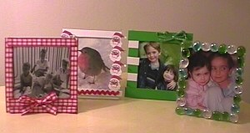
Equipment:
- Empty CD boxes
- Scissors and glue
- Craft supplies and household bits and pieces (see suggestions below)
How to make:
Open the CD box and take out the paper inserts and the moulded plastic piece into which the CD itself fits.
Cut the photo just smaller than the box. The photo will be fitted into the back of the box with the hinged edge at the top, so about 10 cm wide and 12cm high is perfect, but don’t worry too much! Fix the photo against the plastic with a few small pieces of sticky-tape. Find a nice piece of cardboard, gift wrap or fun foam which will complement the design and cut this to fit snugly behind the photo and to the edges of the frame (12cm wide, 13.5 cm high). Fix with glue or sticky-tape with the pattern, if any, facing into the box. When the frame is finished open the box out to stand it up, so this backing protects the photo. Add embellishments.
Here are some embellishment / decorating ideas:
- Sparkly beads – either individual or pre-strung necklaces
- Pearl beads (you may be able to buy an old “pearl” necklace in a charity shop cheaply)
- Jewels (available from craft shops)
- Glass nuggets (for flower arranging, they come in gorgeous colours)
- Tiny silk flowers
- Pretty flower braid, with the individual flowers cut apart and interspersed with silk leaves or green ribbon
- Left over or “odd” doll’s shoes and accessories

Photo Frame from Fun Foam:
Make this simple picture frame from a piece of fun foam.
For each Frame you will need:
- A piece of fun foam a few inches larger than the photo
- a photo to frame
- a hole punch

- scissors
- glue stick
- about 15 cms of thin ribbon or yarn (for hanging the frame)
- fabric paint, sequins, buttons, yarn, ribbon, feathers, etc. (all are optional decorations)

 | Choose a photo to frame.  Decide on a shape for your frame and draw it on a piece of foam. Cut a piece of foam that is at least 3cms larger than the photo on all sides.  All sorts of shapes look good. To cut an oval or heart shape, draw half the shape on a folded piece of paper, then cut it. Use this template for cutting the plastic.
 | Cut a display hole in the other piece of foam (the piece that will be the front). This hole can be any shape you like, just make sure that it is smaller than the entire photo and is big enough to show the important parts of the photograph.
  Put glue on the BACK of the frame. | Glue the back of the frame and glue your picture in place. Cut a thick piece of paper for the back of the frame (it should be slightly bigger than your picture but smaller than the frame). Glue it to the back of the frame.
 | Using a hole punch, punch a hole towards the top of the frame.  Decorate with foam cut-outs, yarn, buttons, feathers, ribbon, fabric paint, sequins, etc.
 | Tie a thin, short ribbon (about 6 inches long) through the hole punch hole. This will be used for hanging the frame.

IFG Explore 1st Year
Term Three – Week Three I Luv Uz Spiritual

Loving Jesus.

Aim: To introduce to the girls Jesus as a friend who loves them and they can love back.

Pre Session Preparation:
- Ask girls to bring a painting shirt if you do not have them available in your resources.
- Cut out in plain cardboard three very large letter “J”s, three “O”s and three “Y”s. This is enough for up to 36 girls as up to four girls can work on each letter (9 x 4 = 36). If you have more girls you will need more sets of letters.

Equipment required
- Stuff to decorate the letters eg glitter, colourful magazines, ribbon, lace etc.
- Paint, paintbrushes, newspaper, felt pens, scissors, glue. Blu Tac or string for displaying.
- Gather some children’s Christian Music DVD’s or CD’s and assemble technology that will enable girls to sing along to the songs.

Coach’s Tip: If you use a CD you may be able to find the actions on Youtube.

Set Up:
Commence with usual set up (roll call etc) at Home Zone.

Devotions
Recap on what the girls learnt the previous two weeks.

“Two weeks ago we learnt that God loves us so we should love ourselves.
(Put up a letter “Y”). Y is for yourself.
“Last week we learnt about caring for others and being kind”.
(Put up a letter “O” to the left of the Y).
“Today we are going to be thinking about someone whose name begins with the letter ”J”. Jesus”.
(Put up the letter “J” to make the word “JOY”. Or you can have some fun mixing up the letters until the girls tell you that you have it right).

“Joy comes from putting Jesus first, others next and yourselves last”.
(Ask girls to tell you what JOY means to them).
“One way we can learn more about loving Jesus and to show that we are full of joy is by singing and that is what we are going to do now”.
You may have some of your favourite children’s songs that reflect this teaching that you can share with the girls.

Some ideas are –
- I’ve got the joy, joy, joy down in my heart
- Joy is a flag flown high from the castle of my heart
- Wide, wide as the ocean
- Oh how I love Jesus
- Jesus loves me
Encourage girls to join in the actions or to dance around).

Teaching Session/Activity:
- At the end of the music session girls can put on their painting shirts and gather round one of the large letters to paint and decorate. This is a team activity with two, three or four girls working on one letter depending on the number of girls in your Unit. Encourage girls to work out their team plan before they get started.
- Display the JOY art work when completed.
- Everyone helps with the clean up and then to the Home Zone to finish with prayer and notices.

Closing Prayer:

Notices:

Home

I Luv Uz Special Activity:
This is an extra activity that you may like to do with your girls over a period of a few weeks. Often in groups, there will be some who finish faster than others, so this could be a “filler” to pick up and work on in those spare moments. This activity could also be used for a Mother’s Day gift.
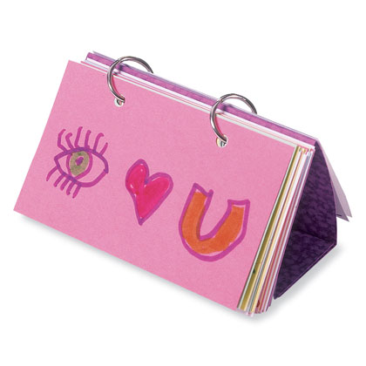
For the activity the girls can write messages, poems, or do drawings showing their love for their parents and their family.

Equipment required:
- Coloured 8 x 13 cm index cards
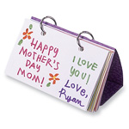
- Hole punch
- Scissors
- Card stock
- Small metal binder rings

How to make:
- Fill a number of coloured 8 x 13 cm index cards with poems, drawings, and heartfelt messages. Use a hole punch to make 2 holes at the top of each card, making sure the holes in all the cards line up.

- To prepare a stand (above, right), cut a piece of colourful card stock into a 13 x 25 cm rectangle, then fold the rectangle in half width wise. Punch 2 holes just below the fold, using one of your punched index cards as a guide. Fold each end of the card stock 2 inches in from the edge, then use scissors to cut a 1-inch slit in the centre of each flap.

- Stack together all of the cards, placing the folded card stock at the bottom of the pile, then bind together all of the pieces using two small metal binder rings (available at office supply shops).

- To set up the flip-book, just interlock the slits in the flaps of the card stock to create a triangular display stand.

